- JRE vs JDK (Youtube- IBM Technology)

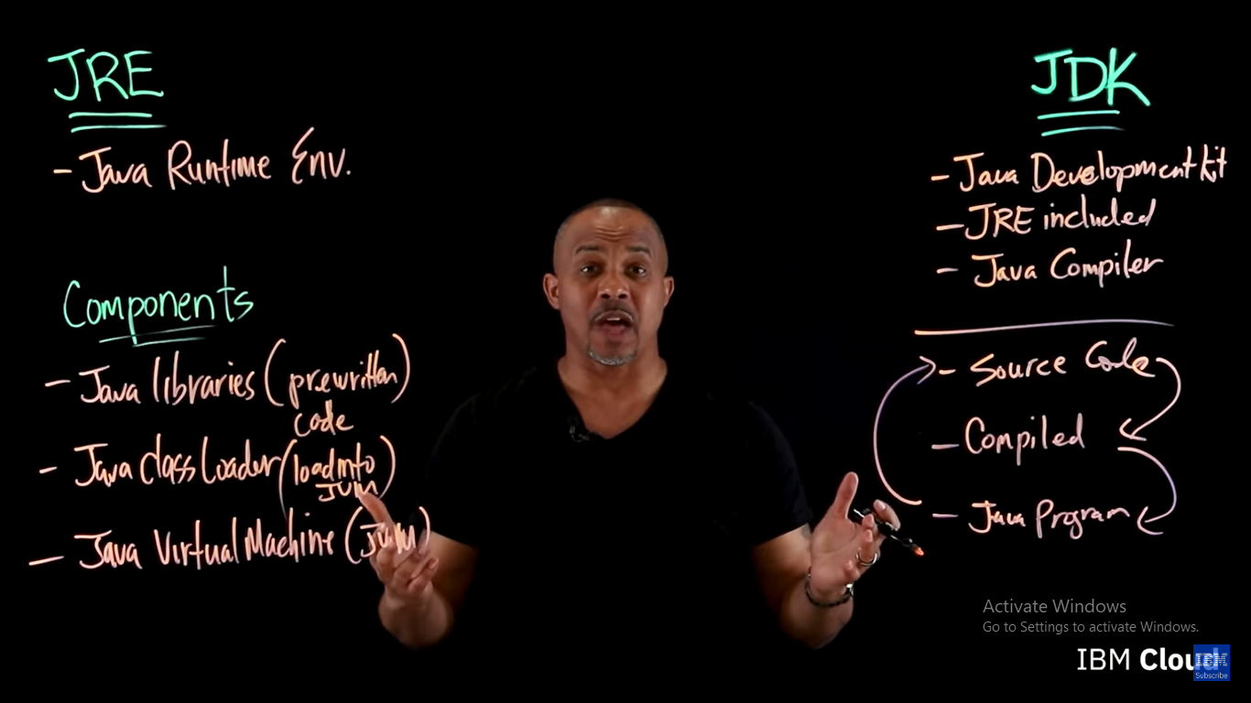

JDK has JRE.
JRE has JVM.
-------------------------------------------------------------------------------------------

2) JDK (youtube- simplilearn)

JDK: JRE, Interpreter, Compiler, Archiver(JAR),
Documentation generator( Javadoc), and some other features

JVM executes a program line by line- work of interpreter
JRE or Java RTE: JVM, Core classes, Supporting files

Class loaders are responsible for loading Java classes dynamically to the JVM (Java Virtual Machine) during runtime.

JDK 9- feature- Java lambda expressions
Lambda expressions- does not need any class to be created
- Concise way to pass functions around
- Replaces bulky anonymous functions

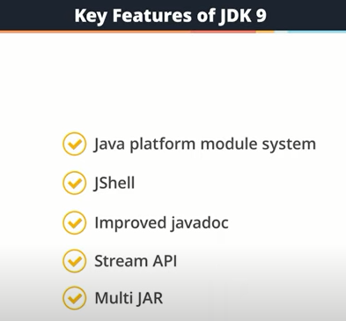
---------------------------------------------------------------------------------------------

3) How Java Works (Youtube- GeeksForGeeks)

Input to JVM: .class (byte code), Interpreter- converts it to machine code\
Java is platform independent but JVM is platform dependent

JDK= JRE + development tools(e.g. compiler, debugger)
JRE= JVM + library classes(e.g. util)
Program files\java\jre/lib

jre\rt.jar\java
rt.jar has libraries like io, util, etc.

Setup environment variables-
To let the OS know javac command jdk\bin - this is where javac bat file is.
Class path- tells the JVM about the required classes

Class loader subsystem is mainly responsible for 3 activities: Loading, Linking, Initialization

https://www.geeksforgeeks.org/jvm-works-jvm-architecture/

------------------------------------------------------------------------------------
Compile time: .java file to .class file

Run time:
Class loader-> Byte code verifier-> Interpreter -> Runtime-> Hardware

When a method is called many times, it’ll be interpreted again and again.
So, for repeated methods JIT provides direct machine code.
JIT- garbage collector
--------------------------------------------------------------------------------------

4) Open JDK vs. Oracle JDK
Open JDK- free to use
Many communities provide OpenJDK. Oracle also provides Open JDK.
Adoptopenjdk- community of Java user group members,
Amazon Corretto with LTS
LTS- Long Term Support

Oracle JDK- paid use -for distributing application in business (client will need to buy license)
But developer doesn’t need to buy license

-------------------------------------------------------------------------------

Every file ending with .java is a class.
--------------------------------------------------------

5) VSCode Java setup
Jdk installation on local machine is needed
Then also need to donwload extension pack for java in VSCode

